Day 22 — Batch Mini Project

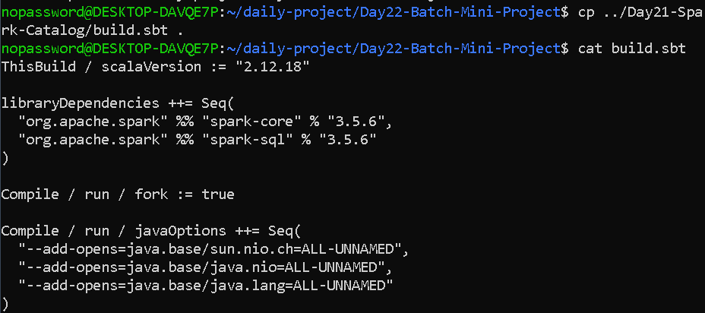

Create transactions.csv
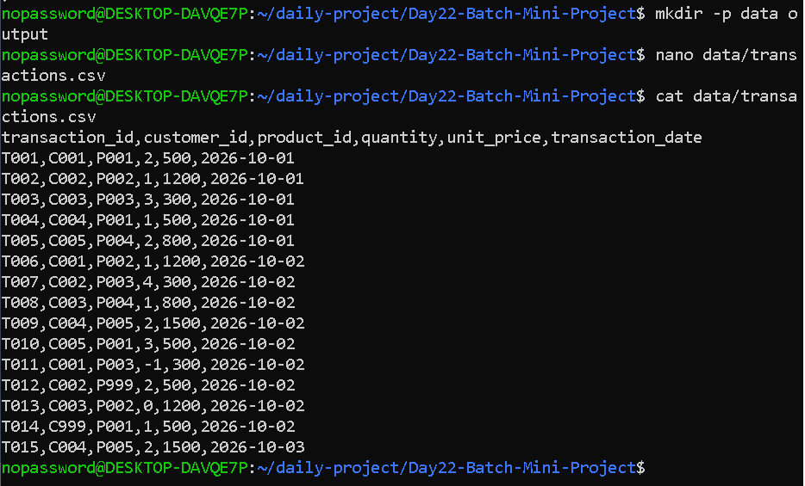

Create customers.csv
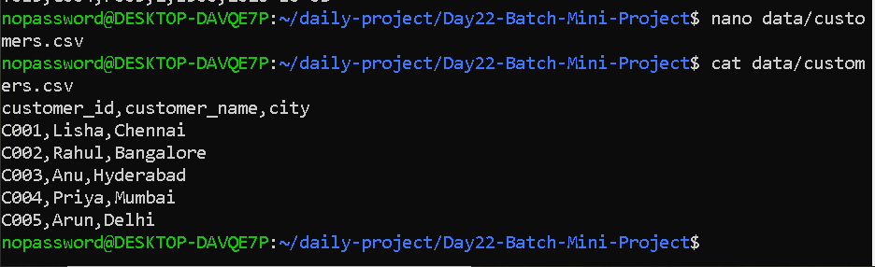

Create products.csv
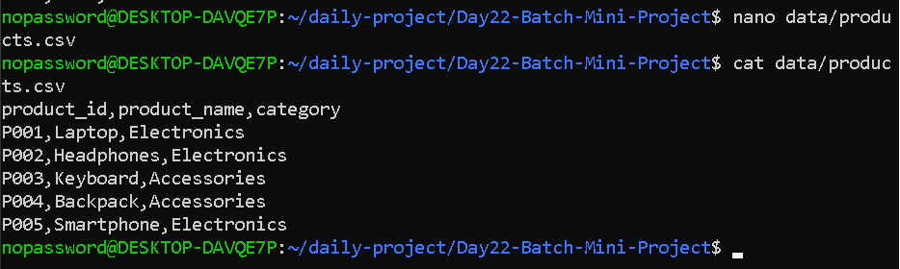

Create the Scala pipeline
nano BatchSalesPipeline.scala

import org.apache.spark.sql.SparkSession
import org.apache.spark.sql.functions._

object BatchSalesPipeline {

def main(args: Array[String]): Unit = {

// Hide Spark console progress
System.setProperty("spark.ui.showConsoleProgress", "false")

// Create Spark session
val spark = SparkSession.builder()
.appName("E-Commerce Daily Sales Pipeline")
.master("local[*]")
.config("spark.driver.bindAddress", "127.0.0.1")
.config("spark.driver.host", "127.0.0.1")
.getOrCreate()

spark.sparkContext.setLogLevel("ERROR")

import spark.implicits._

println("\n==========================================")
println(" DAY 22 - BATCH SALES PIPELINE")
println("==========================================")

// ------------------------------------------------
// 1. Read Raw Transaction Data
// ------------------------------------------------

println("\n1. READING RAW TRANSACTIONS:")

val transactions = spark.read
.option("header", "true")
.option("inferSchema", "true")
.csv("data/transactions.csv")

transactions.show(false)

println("Raw transaction count: " + transactions.count())

// ------------------------------------------------
// 2. Read Customer Data
// ------------------------------------------------

println("\n2. READING CUSTOMER DATA:")

val customers = spark.read
.option("header", "true")
.option("inferSchema", "true")
.csv("data/customers.csv")

customers.show(false)

// ------------------------------------------------
// 3. Read Product Data
// ------------------------------------------------

println("\n3. READING PRODUCT DATA:")

val products = spark.read
.option("header", "true")
.option("inferSchema", "true")
.csv("data/products.csv")

products.show(false)

// ------------------------------------------------
// 4. Clean Invalid Transactions
// ------------------------------------------------

println("\n4. CLEANING INVALID TRANSACTIONS:")

val validTransactions = transactions
.filter(col("quantity") > 0)
.filter(col("unit_price") > 0)
.filter(col("transaction_id").isNotNull)
.filter(col("customer_id").isNotNull)
.filter(col("product_id").isNotNull)
.filter(col("transaction_date").isNotNull)

println(
"Transactions after basic validation: "
+ validTransactions.count()
)

validTransactions.show(false)

// ------------------------------------------------
// 5. Join with Customer Data
// ------------------------------------------------

println("\n5. JOINING WITH CUSTOMER DATA:")

val customerJoined = validTransactions
.join(
customers,
Seq("customer_id"),
"inner"
)

customerJoined.show(false)

println(
"Records after customer join: "
+ customerJoined.count()
)

// ------------------------------------------------
// 6. Join with Product Data
// ------------------------------------------------

println("\n6. JOINING WITH PRODUCT DATA:")

val enrichedSales = customerJoined
.join(
products,
Seq("product_id"),
"inner"
)

enrichedSales.show(false)

println(
"Records after product join: "
+ enrichedSales.count()
)

// ------------------------------------------------
// 7. Calculate Revenue
// ------------------------------------------------

println("\n7. CALCULATING REVENUE:")

val salesWithRevenue = enrichedSales
.withColumn(
"revenue",
col("quantity") * col("unit_price")
)

salesWithRevenue.show(false)

// ------------------------------------------------
// 8. Aggregate Revenue
// ------------------------------------------------

println("\n8. DAILY SALES AGGREGATION:")

val dailySales = salesWithRevenue
.groupBy(
"transaction_date",
"city",
"category"
)
.agg(
sum("revenue").alias("total_revenue"),
sum("quantity").alias("total_quantity"),
count("transaction_id").alias("total_transactions")
)
.orderBy(
"transaction_date",
"city",
"category"
)

dailySales.show(false)

// ------------------------------------------------
// 9. Write Partitioned Parquet Output
// ------------------------------------------------

println("\n9. WRITING PARTITIONED PARQUET:")

dailySales.write
.mode("overwrite")
.partitionBy("transaction_date")
.parquet("output/daily_sales")

println("Parquet output written successfully.")

// ------------------------------------------------
// 10. Read the Output Back
// ------------------------------------------------

println("\n10. READING PARQUET OUTPUT:")

val finalOutput = spark.read
.parquet("output/daily_sales")

finalOutput.show(false)

// ------------------------------------------------
// 11. Display Final Schema
// ------------------------------------------------

println("\n11. FINAL OUTPUT SCHEMA:")

finalOutput.printSchema()

// ------------------------------------------------
// 12. Final Summary
// ------------------------------------------------

println("\n==========================================")
println(" BATCH PIPELINE COMPLETED SUCCESSFULLY")
println("==========================================")

println(
"Final aggregated records: "
+ finalOutput.count()
)

spark.stop()
}
}

OUTPUT—

